

We want to introduce another way to help you build useful and meaningful skills for Alexa quickly. We have launched a new flash cards skill template that makes it easy for developers or non-developers to create a skill similar to “US State Capitals Flash Cards”, “Language Flash Cards”, “Multiplication Tables” etc. This template leverages [AWS Lambda](https://aws.amazon.com/lambda/) and the [Alexa Skills Kit](https://developer.amazon.com/public/solutions/alexa/alexa-skills-kit), while providing the business logic, use cases, error handling and help functions for your skill. You just need to come up with a flash card idea (like “Common Core Mathematics”), plug in your flash card details and edit the sample provided (we walk you through how it’s done). It's a valuable way to quickly learn the end-to-end process for building and publishing an Alexa skill.

Using the Alexa Skills Kit, you can build an application that can receive and respond to voice requests made on the Alexa platform.  In this tutorial, you’ll build a web service to handle notifications from Alexa and map this service to a Skill in the Amazon Developer Portal, making it available on your device and to all Alexa users after certification.

After completing this tutorial, you'll know how to do the following:

* **Create a flash card-based skill** - This tutorial will walk first-time Alexa skills developers through all the required steps involved in creating a flash card based skill.
* **Understand the basics of VUI design** - Creating this skill will help you understand the basics of creating a working Voice User Interface (VUI) while using a cut/paste approach to development. You will learn by doing, and end up with a published Alexa skill. This tutorial includes instructions on how to customize the skill and submit for certification. For guidance on designing a voice experience with Alexa you can also [watch this video](https://goto.webcasts.com/starthere.jsp?ei=1087592).
* **Use JavaScript/Node.js and the Alexa Skills Kit to create a skill** - You will use the template as a guide but the customization is up to you. For more background information on using the Alexa Skills Kit please [watch this video](https://goto.webcasts.com/starthere.jsp?ei=1087595).
* **Get your skill published** - Once you have completed your skill, this tutorial will guide you through testing your skill and sending your skill through the certification process for making it available to be enabled by any Alexa user.

We are going to give you a revised version of the “reindeer games” reference skill and allow you to create a flash card skill quickly. The framework has all of the business logic, use-cases, error handling and help functions already implemented – you just need to plug in your own question/answers and edit a couple lines of script.

Important: Follow the instructions below which step you through setting up the Framework Trivia Game, ‘Reindeer Games’ – be sure you have this working before you move on to adapting it to your set of questions.

To get started: Download the [template logic here](https://github.com/unitygirl/Capitals).

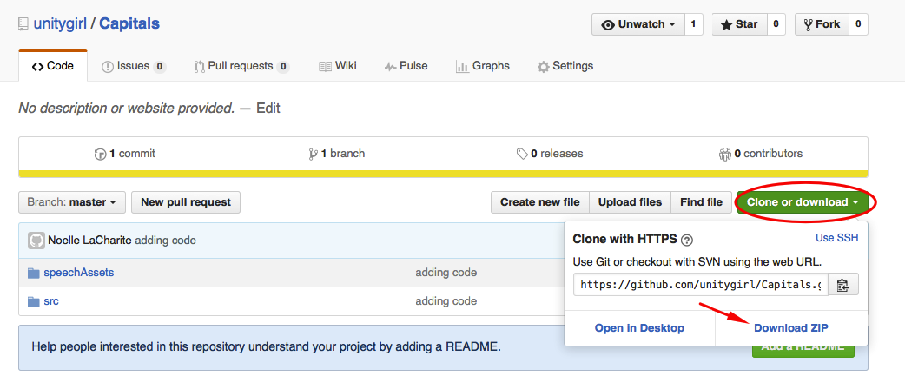

You will also need an AWS account and an Amazon Developer account. To get a refresher on how to do this, or if you are new to skill development, complete the Trivia Skill Tutorial before you continue. This tutorial is built on the trivia template.

## ****Step#1 – Create a new Lambda function****

1.   Select **US East (N. Virginia)** region (upper right)– this is the only region with Alexa/Lambda free tier service

2.   Select Lambda from Compute services (upper left)

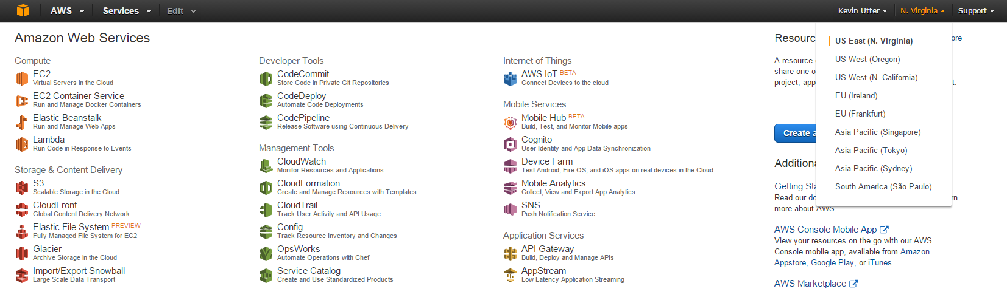

3.   Skip ‘Select Blueprint’

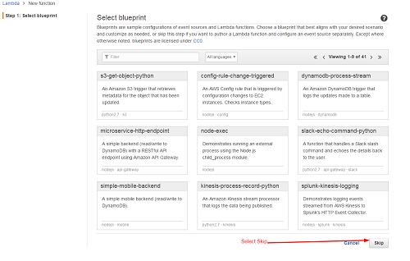

4.   You should be in ‘Configure Function’

* Enter Name/Description/Runtime as in the example below:

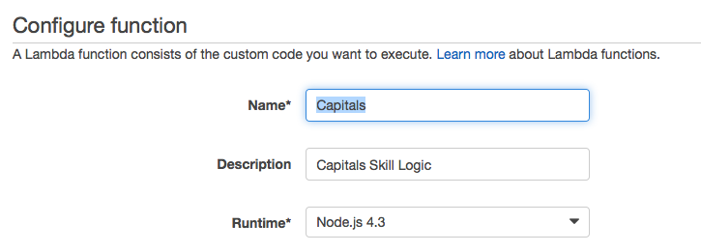

5.   Select the ‘Code Entry Type’ as ‘Edit Code inline’ and copy/paste the Lambda function code   node.js script you downloaded at the start.

6.    Set your handler and role as follows:

a.  Keep Handler as ‘index.handler’

b.  Add a new role for ‘lambda_basic_execution’  (note IAM role in next step. Note also if you have already used lambda you may already have a ‘lambda_basic_execution’ role created you can use.)

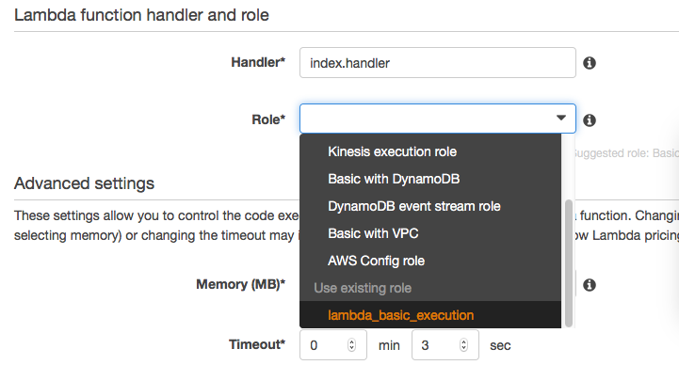

7.   You will be asked to set up your IAM role if you have not done so.

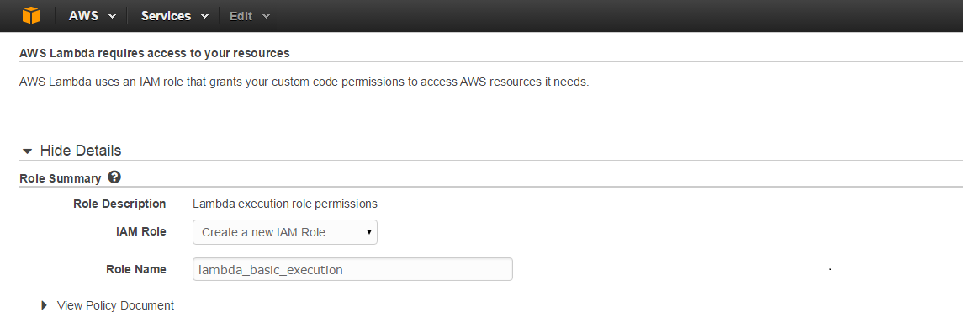

8.   Keep the Advanced settings as default.

* Select 'Next' and review. You should see something like below - Then 'Create your Function':

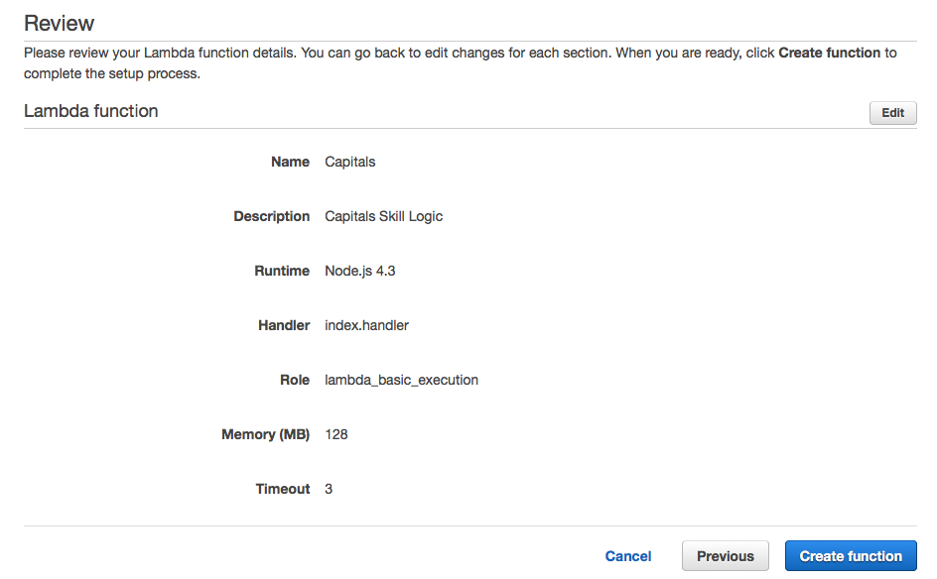

9.   Next we need to create an Event Source

a.   In your Lambda function tabs select ‘Event Source’

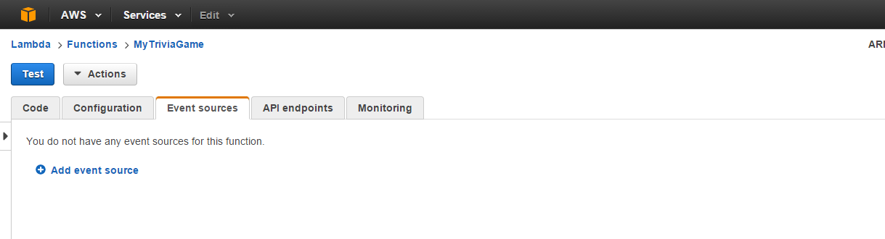

10.   Select ‘Add event source’

a.   Select type as ‘Alexa Skill Kit’

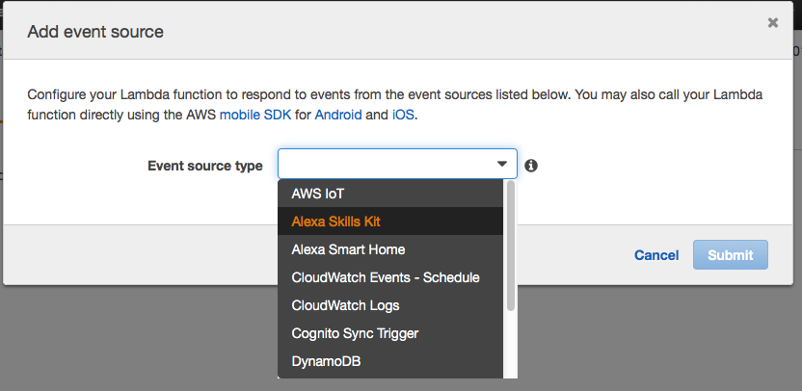

12.   Copy the ARN for your Lambda function; you will need it for setting up your skill in the Developer Portal. You can find your ARN here:

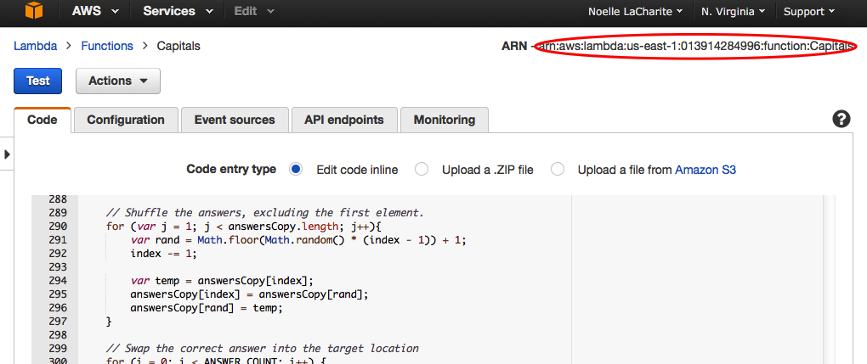

## ****Step#3 – Set Up Skill in Developer Portal****

1.  Sign into your Developer Portal account and navigate to Apps& Services/Alexa/Alexa Skills Kit

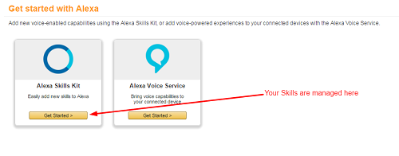

2.  This is where your skill will be defined and managed

1. Select add new skill and add your name/invocation name. Example here:

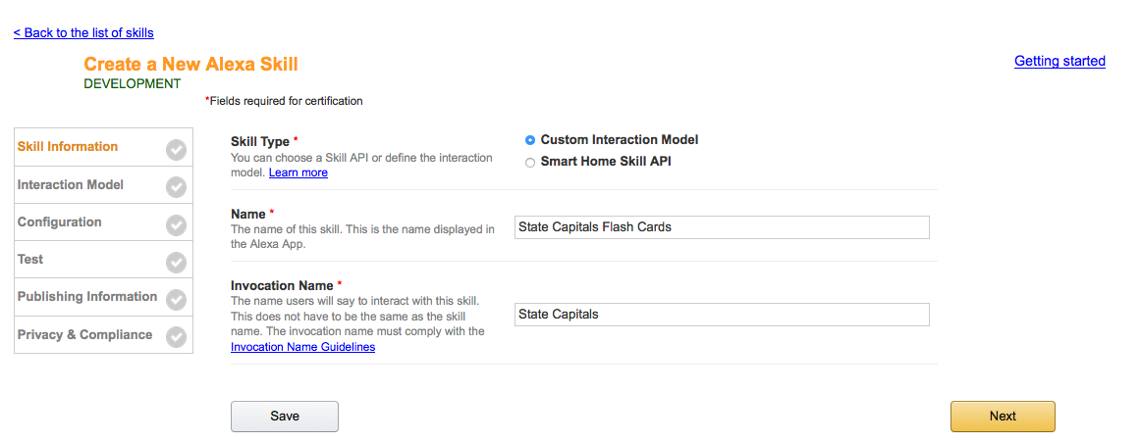

b.  Select Save and Next

c.  We need to define our skill’s interaction model.

1. Copy/paste the following Intent Schema

{

  "intents": [

    {

      "intent": "AnswerIntent",

      "slots": [

        {

          "name": "Answer",

          "type": "LIST_OF_ANSWERS"

        }

      ]

    },

        {

      "intent": "AnswerOnlyIntent",

      "slots": [

        {

          "name": "Answer",

          "type": "LIST_OF_ANSWERS"

        }

      ]

    },

    {

      "intent": "DontKnowIntent"

    },

    {

      "intent": "AMAZON.StartOverIntent"

    },

    {

      "intent": "AMAZON.RepeatIntent"

    },

    {

      "intent": "AMAZON.HelpIntent"

    },

    {

      "intent": "AMAZON.YesIntent"

    },

    {

      "intent": "AMAZON.NoIntent"

    },

    {

      "intent": "AMAZON.StopIntent"

    },

    {

      "intent": "AMAZON.CancelIntent"

    }

  ]

}

1. Add Slot Type as below screenshot:

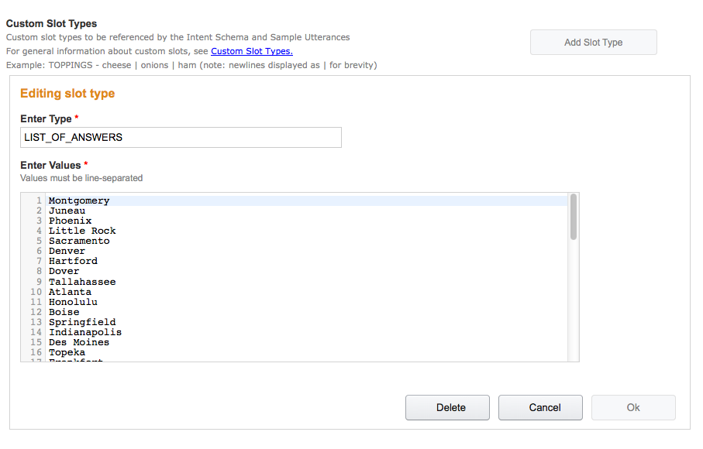

1. Add the Utterances
   1. Copy/paste the following:

AnswerIntent the answer is {Answer}

AnswerIntent my answer is {Answer}

AnswerIntent is it {Answer}

AnswerIntent {Answer} is my answer

AnswerOnlyIntent {Answer}

AMAZON.StartOverIntent start game

AMAZON.StartOverIntent new game

AMAZON.StartOverIntent start

AMAZON.StartOverIntent start new game

DontKnowIntent i don't know

DontKnowIntent don't know

DontKnowIntent skip

DontKnowIntent i don't know that

DontKnowIntent who knows

DontKnowIntent i don't know this question

DontKnowIntent i don't know that one

DontKnowIntent dunno

3.   Select Save and you should see the Model being built (this make a take a minute or 2), then select Next.

  4. In the Configuration Tab, add your ARN endpoint from your Lambda function, select 'No' for account linking, and select Next:

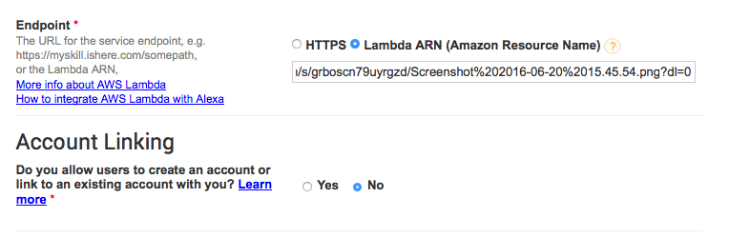

5.   Testing

1. In the Test tab we are going to enter a sample utterance in the service simulator tab.
   1. In this example we have called the skill ‘State Capitals’  – This is the ‘Invocation Name’ we setup on the Skill Information line in step #2.
   2. Enter ‘open state capitals’ and select Ask.
   3. You should see the formatted JSON request from the Alexa Service and response coming back.
   4. Assuming your Echo device is on-line (and logged in with the same account as your developer account) you should now see your skill enabled in the Alexa Companion app and be able to ask Alexa to launch your skill!

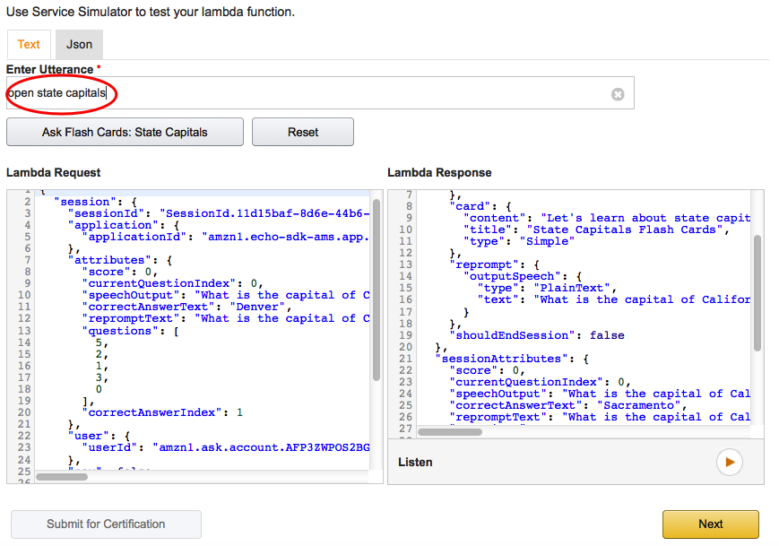

Not working (invalid response)?

* Do you have the right ARN copied from your Lambda function into your Developer Portal / Skill?
* Are you calling the right invocation name?
  + Are you saying Launch, start or open?
  + Are you sure you have NO other skills in your accounts with the same invocation name?
* For this Framework specifically you need to have a minimum of 7 questions/answers for the business logic to function.

## ****Step#4 – Make it Yours****

1.   Edit the Skill Information to reflect your new flash cards.

1. A new **Name**
2. A cool **Invocation Name**
3. A fun **icon**
4. Everything else can stay as is for now in the Developer Portal

2.   Log back into your AWS console and edit the Trivia Game Function you have already created. We are going to copy in your new trivia game questions and answers.

1. As we have elected to edit our code in-line you just need to edit the questions and answers JSON to reflect your trivia game. A few suggestions:
   1. Note than the format calls for one question and 4 answers for each question. The first answer is the correct answer. The script logic takes care of randomizing the questions and answers for you.

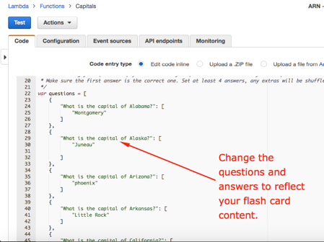

3.   Back to your Developer Portal / Skill for a moment - Copy in your Application ID from the ‘Skill Information’ tab in your developer portal / skill into your lambda script.

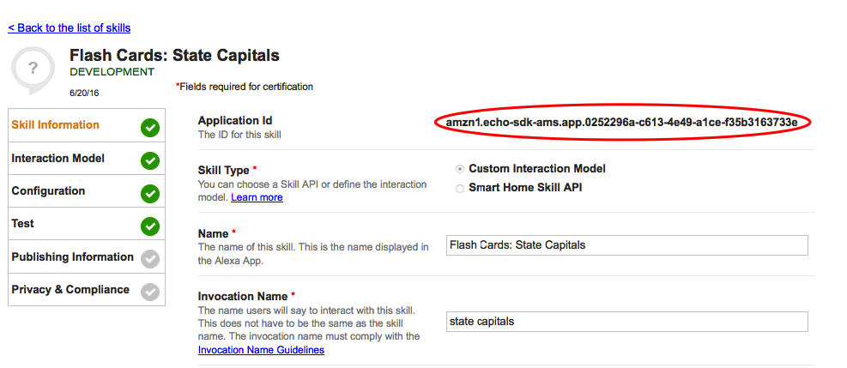

In your AWS lambda function find the applicationId section and copy YOUR Application ID into the section indicated (**do not copy the ID below, which is just an example**) - It looks something like this when you are done: (**be sure to SAVE**)

// Route the incoming request based on type (LaunchRequest, IntentRequest,

// etc.) The JSON body of the request is provided in the event parameter.

exports.handler = function (event, context) {

    try {

        console.log("event.session.application.applicationId=" + event.session.application.applicationId);

        /**

         * Uncomment this if statement and populate with your skill's application ID to

         * prevent someone else from configuring a skill that sends requests to this function.

         */

         if (event.session.application.applicationId !== **"amzn1.echo-sdk-ams.app. amzn1.echo-sdk-ams.app.05aebcb3-1461-48fb-a008-8ddccd1e2b516")** {

         context.fail("Invalid Application ID");

         }

4.   Be sure to remove any State Capital questions (kind of goes without saying)

5.   A minimum of 20 questions is needed to get started, about 100 is a good number to keep users engaged – the more the better.

6.   **Be sure to select SAVE when you are all done. Note: we begin testing in the Developer portal, not in our Lambda function (AWS).**

7.   Now we need to go back to our Developer Portal and test and edit our skill and we will be GO for certification.

a.   In your skills Test tab, enter your Utterances to make sure everything is working with your new questions and answers.

**b.   Go ahead and test with your Alexa enabled device to make sure everything sounds right, you may find a few words that need to be changed for a better user experience.**

**<IMPORTANT>**

Actually run your skill on an Echo device and test every intent and question – the certification team will do this, and you will **FAIL certification** if you have any issues. If you do not have an Alexa device, you can use the [echosim.io](http://echosim.io/) testing tool as well.

    * Does every question and answer sound correct? Do you need to change any words to make them sound correct?

    *   Have you added in YOUR ApplicationID as per the previous instruction?

c.   Select the Description tab next

i.  Spend some time coming up with an enticing, succinct description. This is the only place you have to attract new users and train them how to use your skill. These descriptions show up on the Companion App’s list of new skills available.

ii.   Be sure you have the rights to whatever icons you are uploading – you will need to provide both 108x108px and 512x512px images. If there is any question the certification team will fail your submission.

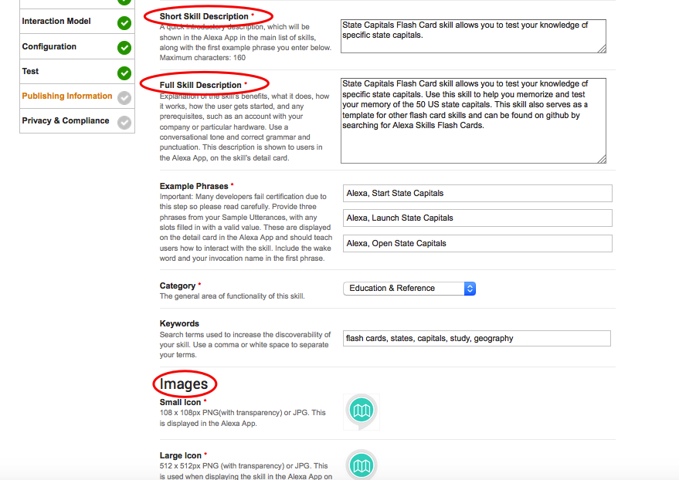

9.   Select Save and SUBMIT FOR CERTIFICATION.

a.    On your Publishing section select ‘No’ for spending money and collecting personal information. Privacy and Terms URLs are optional.

            b.    Note in your testing instructions that you are using the Trivia Game Framework.

c.   You will receive progress e-mails and possibly other suggestions from the team on how you can make your skill even better. You can update your skills at any time.

## ****Alexa Developer Skill Promotion****

We are offering a free Alexa Dev T-shirt to developers who publish an Alexa skill by May 31, 2016. Quantities are limited. To be eligible for this promotion, you must fill out [*this form*](http://www.amazon.com/gp/html-forms-controller/AlexaDevTshirtPromo-April30). See the complete terms and conditions [*here*](https://developer.amazon.com/public/solutions/alexa/alexa-skills-kit/content/alexa-developer-skill-promotion-bloc).